[NL] Open Information Extraction (OIE) Kickoff Meeting - Tue 22 Jul 2025
https://kstate.atlassian.net/wiki/spaces/KL/pages/3672801469/NL+Information+Extraction+IE - for this project
Log in with Atlassian account
Log in to Jira, Confluence, and all other Atlassian Cloud products here. Not an Atlassian user? Sign up for free.
{\"scopeId\":\"51ee0606-5904-4d97-9b75-39f690f0b7c8\",\"storageId\":\"788d6b75-018b-4588-a4b9-a109b3b7d64c@d9a2fa71-d67d-4cb6-b541-06ccaa8013fb\",\"callId\":\"51ee0606-5904-4d97-9b75-39f690f0b7c8\",\"iCalUid\":null,\"exchangeId\":\"\",\"meetingTenantId\":\"d9a2fa71-d67d-4cb6-b541-06ccaa8013fb\",\"modernGroupId\":\"646d9b37-5f36-4c61-9342-153ecb073ae9\",\"meetingOrganizerId\":\"8:orgid:788d6b75-018b-4588-a4b9-a109b3b7d64c\",\"isDeleted\":false,\"originatorParticipantId\":\"5a0dc3e7-2a57-4c6e-9a6e-04588737e460\",\"isExportedToOdsp\":true} Play
How about here?

Nav bar: [Tasks|Teams][Dev|Teams][Lit] [1:T|D|L] [2:T|D|L] [3:T|D|L] [4:T|D|L] [5:T|D|L] [6:T|D|L] [7:T|D|L] [DC|IE]

https://kstate.atlassian.net/wiki/spaces/KL/pages/3672801469/NL+Information+Extraction+IE
Log in with Atlassian account
Log in to Jira, Confluence, and all other Atlassian Cloud products here. Not an Atlassian user? Sign up for free.

https://chatgpt.com/share/687bc5a6-b4e0-8002-87a3-0fb430f1b4e9
ChatGPT - OIE Research Test Bed
Shared via ChatGPT

- closed-loop IR for reasoning-based KB expansion using multimodal LLMs - closest to the open IE project I am working on right now with the volunteer team I brought you into
- agentic QA for clinical trial optimization - this is more of a human-robot interaction (HRI) project in the vein of CoRL and many of the HCI conferences such as CHI, UMAP, maybe CIKM
- continual learning - I have shared some ideas with Yihong about this because she suggested we take a drug discovery approach to anticipatory social media listening; see Mitchell's NELL
- model explainability and trustworthiness for ethics and transparency - chain of custody reasoning in agentic retrieval (and disclosure tracking)
- real-world diagnostic medical applications of computer vision/video - especially for VLMs based on vision transformers, focused on visual identification tasks and top-K cf. Heckerman's Probabilistic Similarity Networks and Knowledge Maps (Heckerman & Geiger)

https://chatgpt.com/share/687bc076-cfd8-8001-9051-baf379ff9afa
ChatGPT - TikTok Search Query Generator
Shared via ChatGPT

https://cs-kdd-nl-llm.kdd.cs.ksu.edu/

Ollama deployment for KDD

Here are the list of llms that can me deployed: https://ollama.com/library
library
Browse Ollama's library of models.

Patrick: Generative search via resampling from latent posterior distribution
more-like-this (MLT) using LLM Query generation 8:orgid:21b165d3-c410-4f86-b743-d7623328c103Manny Adeniji35678:orgid:788d6b75-018b-4588-a4b9-a109b3b7d64cWilliam Hsu35678:orgid:4df2a4ef-cc74-4ade-a807-70f69a90d1c3Patrick Stingley35678:orgid:2a55dc90-e219-4be3-97d0-94f9c8fbc08dJames Chapman35678:orgid:274e836a-acf4-4053-a5c2-fa2c2a67d8d8Jahid Chowdhury Choton356728:bdd75849-e0a6-4cce-8fc1-d7c0d4da43e535678:orgid:b7e87e95-c9d7-42a0-8b91-92685534ae31JIA Shuyue3567callEnded 07/22/2025 21:56:14 https://api.flightproxy.teams.microsoft.com/api/v2/ep/conv-uswe-05-prod-aks.conv.skype.com/conv/UddmRtvlGEuzf7jTv62viQ?i=10-128-54-15&e=638884697853119484 51ee0606-5904-4d97-9b75-39f690f0b7c8 False Play Play
Jahid, Patrick, James, Manny, Shuyue (Bruce): Thanks for joining yesterday.
Yihong, Timothy, Mobina, David, Ahsan, Logan, Wesley: FYI

Added to OIE Confluence hub:
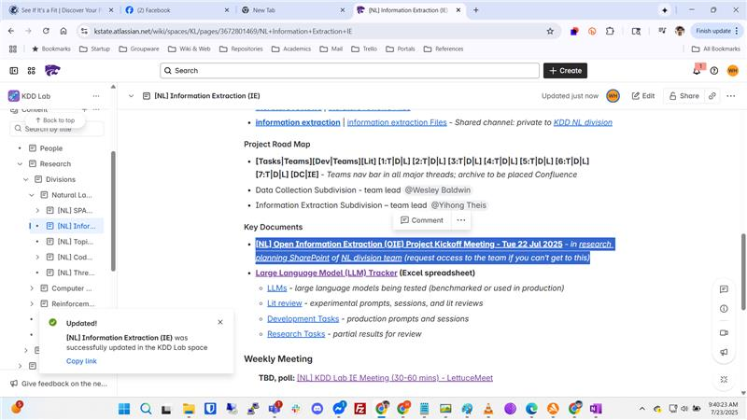
Log in with Atlassian account
Log in to Jira, Confluence, and all other Atlassian Cloud products here. Not an Atlassian user? Sign up for free.

